DBMS LAB – SQL TRANSACTIONS (2)

NAME: G.DARSHINI
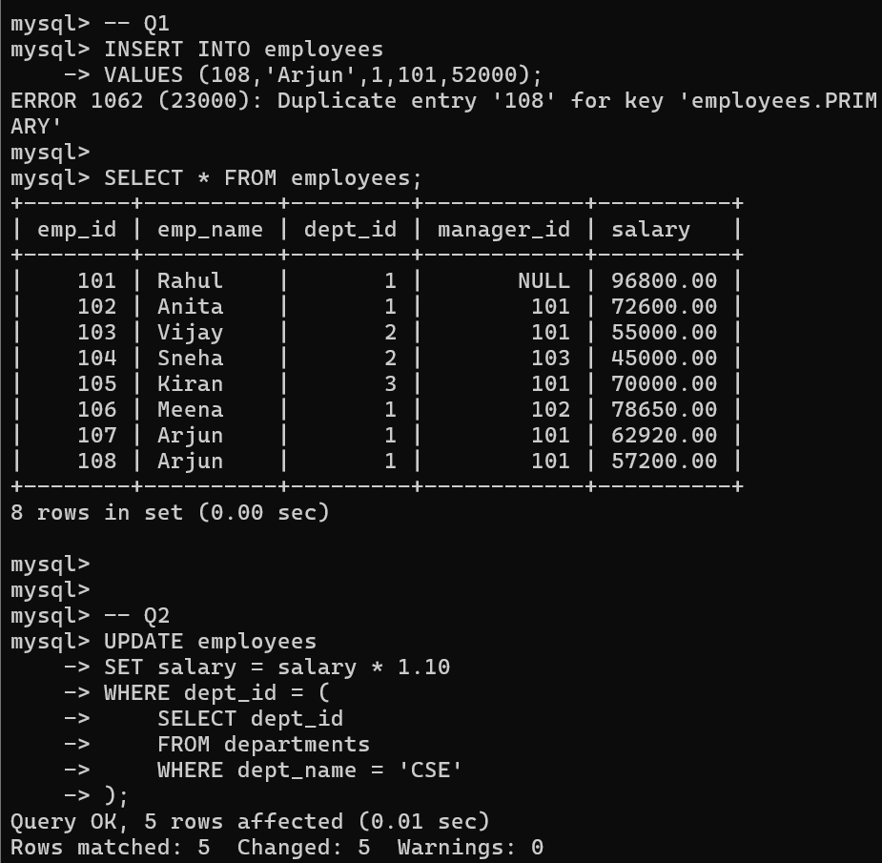

mysql> DELETE FROM employees
-> WHERE salary< 30000;
Query OK, 0 rows affected (0.00 sec)
mysql>
mysql> SELECT* FROM employees;
+--------+----------+---------+------------+ +
I emp_id I emp_name I dept_id I manager_id I salary
+--------+----------+---------+------------+ +

- Rahul
- Anita
- Vijay
- Sneha
- Kiran
- Meena
- Arjun

1 NULL 106480.00
1 101 79860.00
2 101 55000.00
2 103 45000.00
3 101 70000.00
1 102 86515.00
1 101 69212.00

- Arjun 1 101 62920.00
+--------+----------+---------+------------+ +
8 rows in set (0.00 sec)
mysql> mysql>
mysql> -- Q4
mysql> SELECT* FROM employees;
+--------+----------+---------+------------+ +
I emp_id I emp_name I dept_id I manager_id I salary
+--------+----------+---------+------------+ +

- Rahul
- Anita
- Vijay
- Sneha
- Kiran
- Meena
- Arjun

1 NULL 106480.00
1 101 79860.00
2 101 55000.00
2 103 45000.00
3 101 70000.00
1 102 86515.00
1 101 69212.00

- Arjun 1 101 62920.00
+--------+----------+---------+------------+ +

-> FROM departments d
-> ON d.dept_id = e.dept_id;
+-----------+ +
I dept_name I emp_name I
+-----------+ +
-> LEFT JOIN employees e
CSE Arjun
CSE Arjun
CSE Meena
CSE Anita
CSE Rahul
ECE Sneha
ECE Vijay
MECH Kiran
Civil NULL
+-----------+ +
9 rows in set (0.00 sec)
mysql> mysql> mysql> -- QB
mysql> SELECT e.emp_name AS Employee,
-> m.emp_name AS Manager
-> FROM employees e
-> ON e.manager_id = m.emp_id;
+----------+ +
I Employee I Manager I
+----------+ +
-> LEFT JOIN employees m
Rahul NULL
Anita Rahul
Vijay Rahul
Sneha Vijay
Kiran Rahul
Meena Anita
Arjun Rahul
Arjun Rahul
+----------+ +
8 rows in set (0.00 sec)

-> GROUP BY dept_name;
I dept_name I AverageSalary I
I MECH 10000.000000 I
-> HAVING AVG(salary) > 6
I dept_name I AverageSalary I
I MECH 70000.000000 I
-> FROM employees;
I HighestSalary I LowestSalary I
106qa0.00 I qs000.00 I
mysql> -- Q10
mysql> SELECT dept_name,
-> AVG(salary) AS AverageSalary
-> FROM employees e
-> JOIN departments d
-> ON e.dept_id = d.dept_id
+-----------+ +
+-----------+ +
I CSE a0997.Q00000 I
I ECE s0000.000000 I
+-----------+ +
3 rows in set (0.00 sec)
mysql> mysql> mysql> | -- Qll
mysql> SELECT dept_name,
-> AVG(salary) AS AverageSalary
-> FROM employees e
-> JOIN departments d
-> ON e.dept_id = d.dept_id
-> GROUP BY dept_name
0000;
+-----------+ +
+-----------+ +
I CSE 80997.Q00000 I
+-----------+ +
2 rows in set (0.00 sec)
mysql> mysql> mysql> | -- Q12
mysql> SELECT MAX(salary) AS HighestSalary,
-> MIN(salary) AS LowestSalary
+---------------+ +
+---------------+ +
+---------------+ +
1 row in set (0.00 sec)

mysql> -- Q16
mysql> SELECT dept_name,
-> COUNT(*) AS EmployeeCount
-> FROM employees e
-> ON e.dept_id = d.dept_id
-> GROUP BY dept_name
-> HAVING COUNT(*)> 5;
Empty set (0.00 sec)
-> JOIN departments d
mysql> mysql>
mysql> -- Q17
salary
mysql> SELECT emp_name,
-> FROM (
-> SELECT emp_name,
-> salary,
-> DENSE_RANH() OVER (ORDER BY salary DESC) AS rnk
-> FROM employees
->) AS ranked
=
-> WHERE rnk 2;
+----------+ +
I emp_name I salary
+----------+ +
I Meena I 86515.00 I
+----------+ +
1 row in set (0.00 sec)
mysql> mysql>
mysql> Q18
mysql> SELECT emp_name, salary
-> FROM employees e
-> WHERE salary> (
-> SELECT AVG(salary)
-> FROM employees
=
-> WHERE dept_id e.dept_id
-> );
+----------+ +
I emp_name I salary
+----------+ +
I Rahul 106Q80.00 I
I Vijay 55000.00 I
I Meena 86515.00 I
+----------+ +
3 rows in set (0.00 sec)

